AI-BASED JOB RE-APPLY NOTIFIER

Submitted By:
Name: Ramya V
Department: B.Sc. Computer Science
College: Chevalier T. Thomas Elizabeth College for Women (Arts & Science), Chennai
Start Date: 28/11/2025

End Date: 30/11/2025

1. ABSTRACT
The recruitment processes of many companies include policies related to reapply restrictions and candidate data retention. These details are communicated through long emails, rejection messages, and privacy notices that applicants often overlook. As a result, job seekers frequently remain unaware of when they are eligible to reapply to a company or how long their data is stored in the organization’s system.
This project, titled AI-Based Job Re-Apply Notifier, aims to solve this problem by developing a smart web application that uses Natural Language Processing (NLP) to analyze recruitment-related text and extract key rules such as reapply duration and data retention period. The system then calculates the exact date on which the user becomes eligible to reapply. A dashboard with status indicators helps applicants keep track of multiple companies and reapplication schedules. This AI-driven automation improves clarity, reduces manual effort, and helps job seekers plan their career activities more effectively.

2. INTRODUCTION
Every year, millions of candidates apply for job positions across various industries. When an applicant submits a job application, the company may store their data and restrict repeat applications for a specific period. These rules are typically detailed inside long candidate policies, automated emails, or privacy notices. Most applicants ignore or do not understand these details, which leads to problems such as:
- Trying to apply again too soon
- Seeing “You are already registered” errors
- Missing reapply eligibility windows
- Uncertainty about their application status
To address this problem, the AI-Based Job Re-Apply Notifier provides a solution that intelligently analyzes recruitment emails using AI and automatically calculates reapply eligibility dates. It presents the information in a user-friendly dashboard that displays status indicators (e.g., eligible, not eligible yet). This empowers job seekers with clarity and reduces confusion in their job application journey.

3. PROBLEM STATEMENT
Job applicants often face the following issues:
- No clarity about reapply rules
Companies specify reapply waiting periods like “You can reapply after 6 months,” but users often miss this information.
- Difficulty understanding long privacy notices
These texts contain legal language and are time-consuming to read.
- No proper system to track reapply dates
Users cannot remember when they applied or when they are allowed to reapply.
- Errors while attempting to reapply
Many job portals show “Already registered” messages because users unknowingly try to reapply too early.
- Lack of centralized tracking per company
Applicants apply to multiple companies and lose track of each company’s rule.
This project solves all these issues using automation and AI.

4. OBJECTIVES
The main objectives of this project are:
- To automate the extraction of reapply rules from recruitment-related text.
- To identify data retention durations using AI text-analysis techniques.
- To compute reapply dates using safe mathematical operations on dates.
- To offer a centralized dashboard showing all job applications.
- To classify each application with a color-coded status:
  - Red: Not eligible
  - Yellow: Nearly eligible
  - Green: Eligible to reapply
- To reduce confusion and improve clarity in managing job applications.
- To help job seekers plan applications more systematically.

5. EXISTING SYSTEM VS PROPOSED SYSTEM

Existing System
- Users manually read recruitment emails.
- No automation for detecting reapply waiting periods.
- Misinterpretation of legal/privacy texts.
- No tool to calculate reapply dates.
- No centralized system to track multiple job applications.
- High chances of errors or missed opportunities.

Proposed System
- AI automatically reads and analyzes text to extract rules.
- Auto-calculates reapply eligibility using date logic.
- Simple dashboard to display all applications.
- Color-coded status for easy tracking.
- Reduces manual effort and confusion.
- Provides personalized reapply notifications.

6. SYSTEM DESIGN
The system consists of the following key components:

1. User Interface Layer
- Built using React
- Allows users to input job-related information
- Displays results, dates, and statuses

2. Backend Application Layer
- Developed using Python Flask
- Handles data processing, AI extraction, and date calculation

3. AI Text Analysis Module
- Extracts useful patterns from text
- Identifies reapply and data retention sentences
- Uses regex + NLP techniques

4. Database Layer
- Stores job applications
- Stores user details (if login system included)
- Stores extracted AI results

7. ARCHITECTURE DIAGRAM (TEXT FORMAT)
┌───────────────────────┐
│ FRONTEND UI │
│ (React Application) │
└───────────┬───────────┘
│
▼
┌───────────────────────┐
│ REST API │
│ (Flask Backend) │
└───────────┬───────────┘
│
▼
┌───────────────────────┐
│ AI ANALYSIS ENGINE │
│ (Regex + NLP Methods) │
└───────────┬───────────┘
│
▼
┌───────────────────────┐
│ DATABASE │
│ (MySQL / MongoDB) │
└────────────────────────┘

8. MODULE DESCRIPTION

1. User Input Module
- Collects company name, role, applied date
- Accepts pasted text (policy/email content)

2. AI Analysis Module
- Scans the text
- Extracts phrases like “6 months”, “12 months”, “1 year”
- Identifies whether the extracted duration refers to:
  - Reapply waiting period
  - Data retention period

3. Date Calculation Module
- Converts durations into final dates
- Example:
  - Applied: 25–11–2025
  - Reapply waiting period: 6 months
  - Reapply date: 25–05–2026

4. Dashboard Module
- Displays all saved job applications
- Shows reapply dates & retention end dates
- Color-coded statuses for clarity

5. Status Classification Module
- Logic:
  - Today < reapply date → Red
  - Today within 30 days → Yellow
  - Today ≥ reapply date → Green

9. TECH STACK

Frontend
- React
- HTML
- CSS
- JavaScript

Backend
- Python
- Flask Framework

AI Logic
- Regex
- NLTK / spaCy (optional)
- Rule-based text classification

Database
- MySQL or MongoDB

Deployment
- GitHub (source code)
- Render / Netlify (hosting)

10. ALGORITHMS (AI TEXT ANALYSIS)

Step 1: Sentence Splitting
Split text into sentences.

Step 2: Duration Extraction Using Regex
Pattern used:
(\d+)\s*(day|days|month|months|year|years)

Step 3: Classification
Check for keywords:
- If sentence contains "reapply", "apply again", -> reapply rule
- If sentence contains "retain data", "data stored", -> retention rule

Step 4: Date Calculation Algorithm
- Add days
- Add months (handle month overflow)
- Add years
- Handle leap year cases

11. DATABASE DESIGN

ER DIAGRAM (TEXT FORMAT)
User (1) ────< (Many) Applications

TABLES

users
- user_id (PK)
- name
- email
- password

applications
- app_id (PK)
- user_id (FK)
- company_name
- role
- applied_date
- reapply_date
- data_retention_end
- raw_text
- status

12. SCREENSHOTS (PLACEHOLDER DESCRIPTIONS)
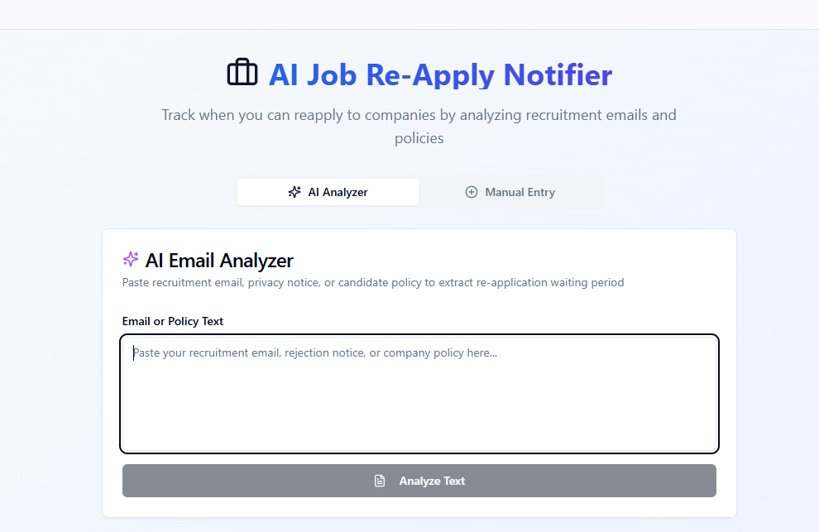
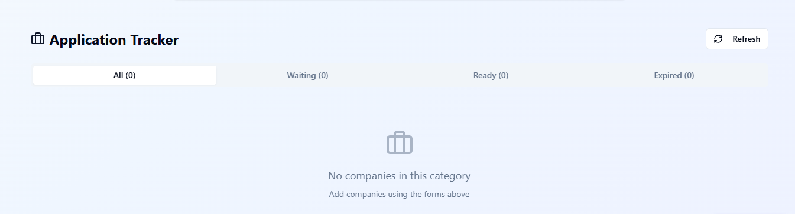

13. CONCLUSION
The AI-Based Job Re-Apply Notifier successfully automates the extraction of reapply rules from recruitment-related text. The system provides clear, accurate, and fast insights into when users can apply to companies. This project reduces confusion, improves productivity, and supports better job planning. It demonstrates intelligent use of AI and web technologies in a practical real-world scenario.

14. FUTURE ENHANCEMENTS
- Automatic extraction from email inbox
- Mobile app version
- Advanced transformer-based NLP (BERT, GPT)
- Automatic notifications to email/SMS
- AI-based resume matching and suggestions
- Integration with job portals

